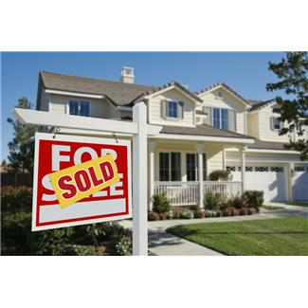

# Our Community’s Flood Hazard

What Prospective Property Owners Should Know

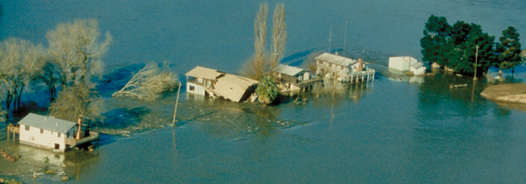\

Village of Island Park

Contact the Village Building Dept at:

516-431-0600

*www.villageofislandpark.com*

Ask Before You Buy:

Know Your Flood Risk!

Our Situation: A large portion of the Village is subject to periodic flooding caused by surges in Hog Island Channel, and the various other channels accessory to the Atlantic Ocean. In 2012, Hurricane Sandy produced extreme water surface elevations and damage in the Village. If you are looking at buying a property, it is a good idea to check out the possible flood hazard before you buy.

* **Know Your Local Floodplain Management Regulations**. The Villageregulates construction and development in identified floodplains to ensure buildings are protected from flood damage. Filling and similar projects are prohibited in certain areas. Houses that are considered substantially damaged (i.e., more than 50% of its market value) by fire, flood or other causes must be elevated to above the flood level when they are repaired.
* **Flood Protection.** A building can be protected from most flood hazards, sometimes at relatively low cost. New buildings and additions can be elevated above the flood levels. Existing buildings can be protected from shallow floodwaters with some simple retrofitting measures. Contact our Building Department for more detailed information.

# For Your Protection

Know Your Flood Risk

# Other Resources

What You Should Know

# Flood Insurance Rate Maps

http://msc.fema.gov

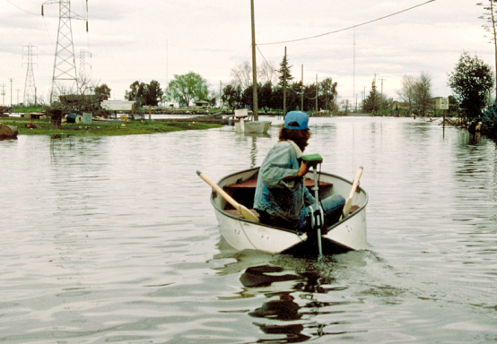air photo based flood zone map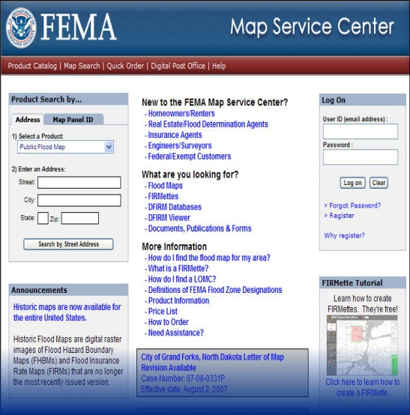

* You can check on Special Flood Hazard Areas in your neighborhood by looking at the Flood Insurance Rate Maps at FEMA’s Map Service Center: <http://msc.fema.gov>.
* Most city and county government building or planning departments have the FEMA maps, too. Contact the Village of Island Park Building Department for more information on special land use, building, or floodplain management regulations that apply.
* Looking for a new home? Have you checked out whether it has ever flooded or had a drainage problem? Even a shallow flood that is only a few inches deep in your house could cause thousands of dollars in damage, and loss of irreplaceable keepsakes. Deeper floods mean you will have to relocate until repairs are made.
* The Federal Emergency Management Agency (FEMA) has prepared Flood Insurance Rate Maps (FIRMs) that show Special Flood Hazard Areas (SFHAs). If your property is in a Special Flood Hazard Area, it is five times more likely to experience a flood versus a fire, so flood insurance is advisable.
* If you need a mortgage that is regulated or insured by the Federal government (e.g., VA, FDIC, Farm Credit, OCC, FHA/HUD, OTS, SBA, NCUA), you will have to buy a flood insurance policy if the building is in a Special Flood Hazard Area.
* New York state law requires sellers or their agents to disclose knowledge of any natural hazards on their property, including flooding, so start your research by asking the seller and the agent. They may honestly say they don’t know of any flooding, but that does not mean it is not located in a Special Flood Hazard Area.

**D Zones = Undetermined**